­

Contents

Pass – Ethanol-Preliminary Findings 2

Pass Print 6

# Pass – Ethanol-Preliminary Findings

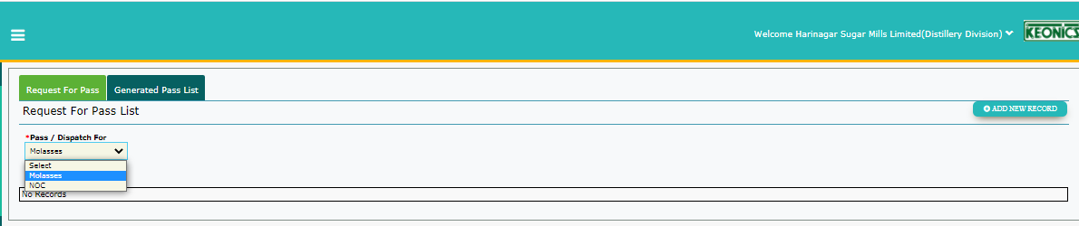

|  |  |  |
| --- | --- | --- |
| Findings | Developer Comments | Retested Status/comments |
| “Molasses” option to be removed as distillery does not raise pass for molasses. | Option is required for both | Error invalid due to change in requirements.  Note: Currently displays two options RR, NOC |

Raising pass for the below NOC

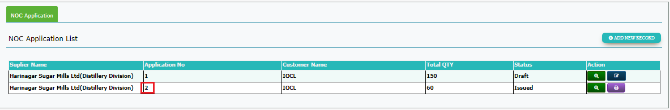

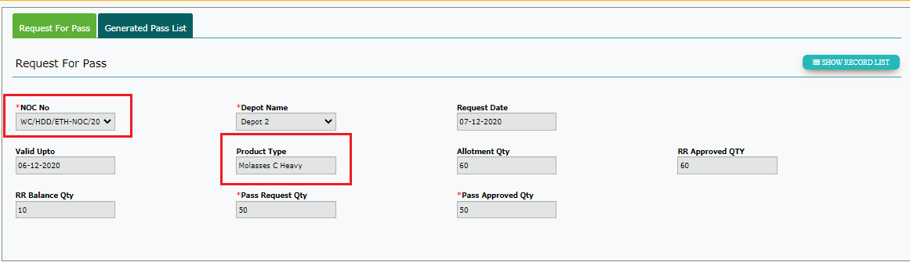**Request for Pass**

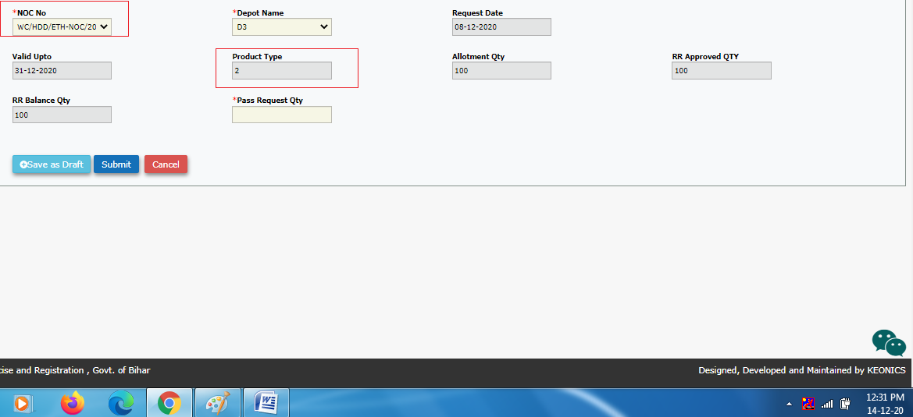

|  |  |  |
| --- | --- | --- |
| Findings | Developer Comments | Retested Status/comments |
| NOC – “2” number NOC approved and Issued. (Ref img 1) . NOC number not visible completely in Request for Pass form  **UI**: Increase the text box size.  Tested: Fixed | fixed | Fixed |
| Raising pass through NOC for ethanol- **Add new Record.**  Product Type : Number is displayed.  Expected: It should display “Ethanol”  NOTE*: IN list screen it is displayed as “Ethanol”* | fixed | Fixed |
| Raising pass through NOC for ethanol**- View Mode**  Product Type : “ Molasses C Heavy” is displayed.  Expected: It should display “Ethanol”  NOTE*: In list screen it is displayed as “Ethanol”* | fixed | Fixed |
| **UI:** RR is raised by distillery unit for Molasses Release Request and pass will be raised by SM.  **UI Could be changed to RR/NOC Approved/Balance/Alloted** | fixed | Partial Fix- Currently displayed as **Approved/Balance/Alloted only.** No prefix is added.(Might confuse regarding which qty) |
| UI - Label to be changed appropriately.   * “NOC/RR approved Qty”instead of RR approved Qty * “NOC/RR balance Qty” instead of RR balance Qty | Fixed.Removed RR/NOC | Partial Fix- Currently displayed as approved Qty or balance Qty **only.** No prefix is added. .(Might confuse regarding which qty) |
| Pass Number generated is not in the correct format and sequence.  Expected: To be generated in format and sequence. | fixed | Fixed |

**Request for Pass List**

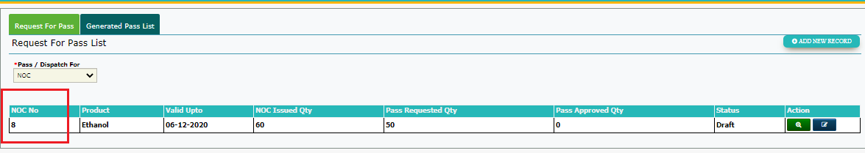

1. Approved NOC number to be displayed. – Not fixed(Also the value is incrementing than the one inside the form)

|  |  |  |
| --- | --- | --- |
| Findings | Developer Comments | Retested status/Comments |
| **BO Login**  BO Rejects the Pass request then Status in the list screen is “Rejected” but Under “Pass Approve Qty” displaying Value. | fixed | Fixed  Displayed as 0 |
| **Dis Login**  In the above mentioned case pass was not approved . Still rejected qty is deducted. Displaying    Expected:If pass is rejected then qty should not be deducted . “Balance qty should be calculated accordingly” | fixed | Fixed |
| **Dis Login**    Messages displayed to be appropriate wrt to distillery .  UI: “Request Qty….RR/NOC Balance Qty!!” | fixed | Fixed |
| **Dis Login: Generate Pass**  Displaying All type of VATS  Expected: “From Dispatch Vat “ should display only “Dispatch Vat “ . | fixed | Partial Fix.  Cureently displays MST and Dispatch VATs. Should display based on the pass raised. |
| **Dis Login: Generate Pass**  As Dispatch VATS are empty , to check the available balance selected different VATS . Checked for 3 VATS (F1, MST1 and Storage 1) didn’t save/ save as draft . But 3 records are generate.  Record should be listed only when save as draft/submit | TBC | Fixed |

**BO Login: Generate Pass List**

|  |  |  |
| --- | --- | --- |
| **Findings** | Developer Comments | Retested Status/Comments |
| NOC number displayed not in format  Expected : NOC issued/displayed in list and in form should be consistent across the dispatch process | fixed | Fixed |
| User raised pass for an expired NOC  Expected : Some alert Pop up is required/ NOCs expired should not be listed in pass application form . | TBC | TBT |

**Dis Login: Generate Pass List**

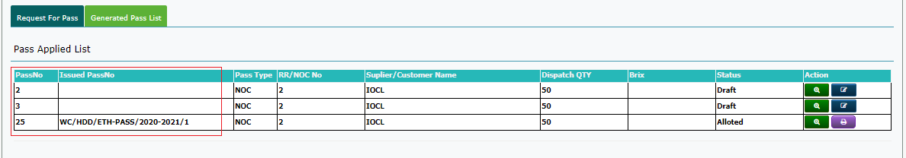

Pass No sequence to be maintained-fixed

Fixed

# Pass Print

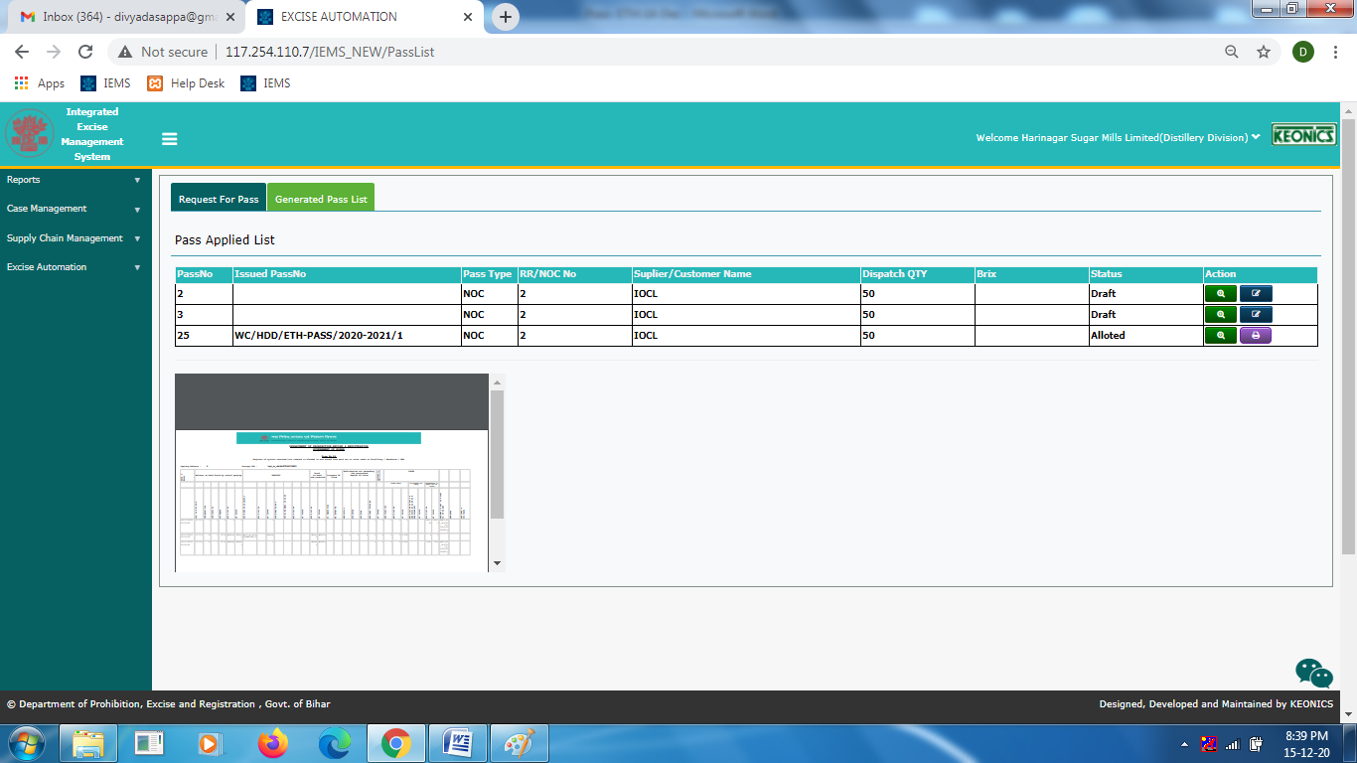When clicked on print button . Pass form is displayed as below-fixed

Fixed

18-12-2020 Findings

Used logins for reference: newswadeshi_dis,newswadeshi_disbo

1. After the raised pass for ethanol by distillery is approved by distillery BO, in distillery login🡪 Click on Generate Pass🡪Choose from Dispatch VAT🡪 Drop down displays both ethnol and molasses storage vats.

Instead the Dispatch VAT drop down should display based on the product the pass is raised for.

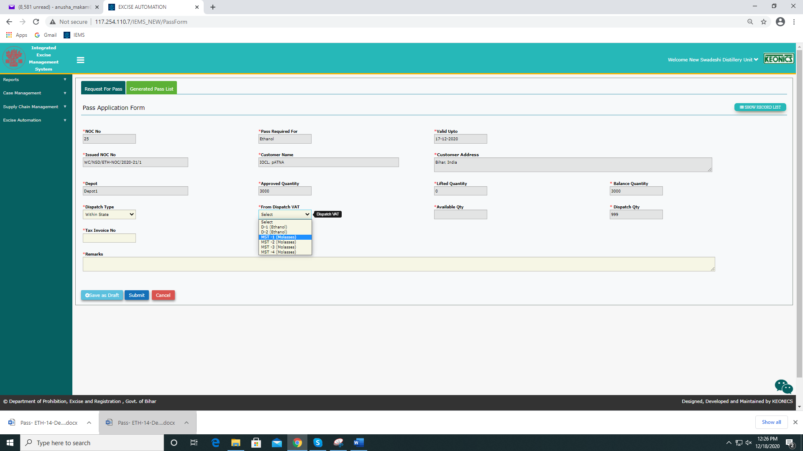

1. In distillery login, as shown Nothing is transferred to Dispatch VAT. Opening balances in D-1 is 8000 and D-2 is 900 respectively. But when seen in Generate Pass form in distillery login after selecting the particular vat from drop down, the values are D-1 16000 AND D-2 1800. This is double of the existing value. Correct values are not displayed.

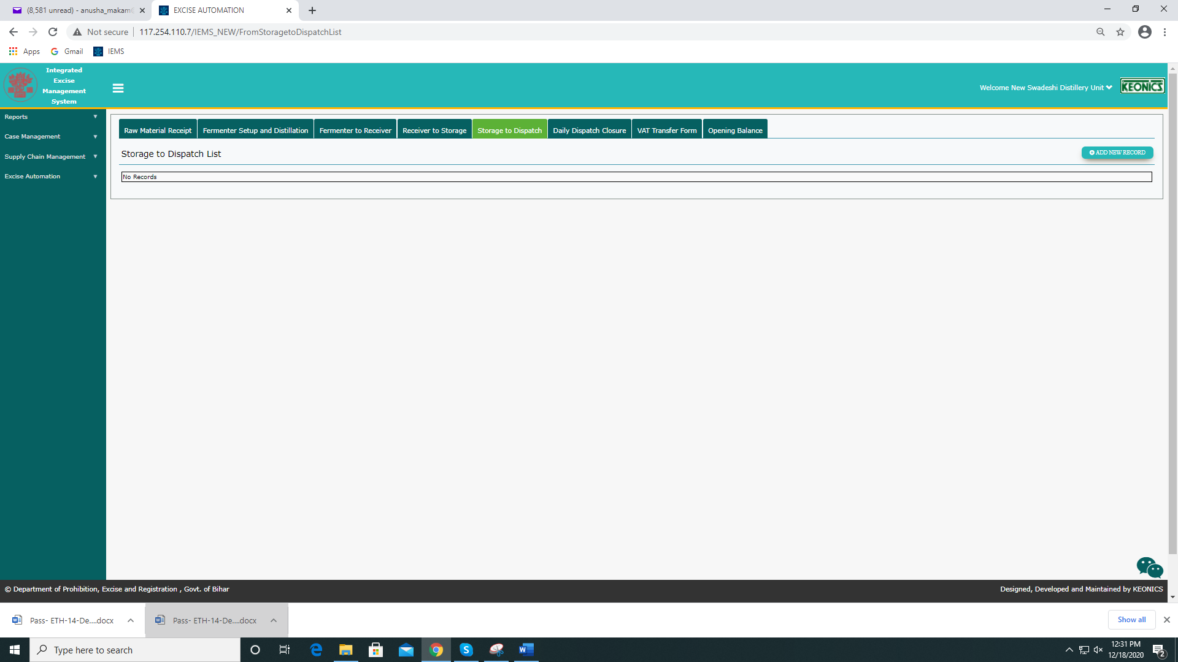

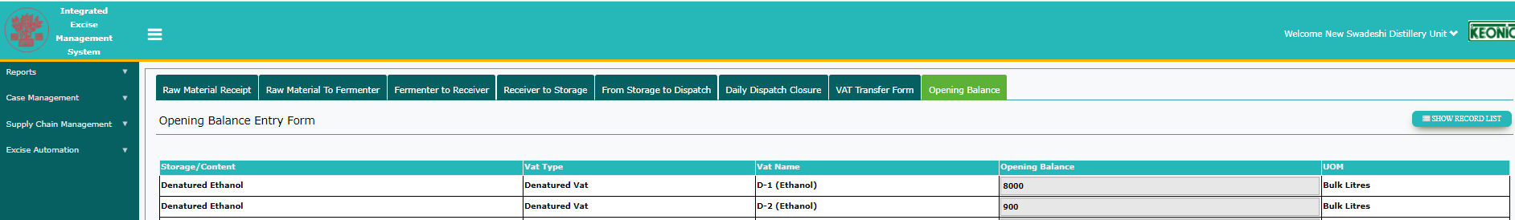

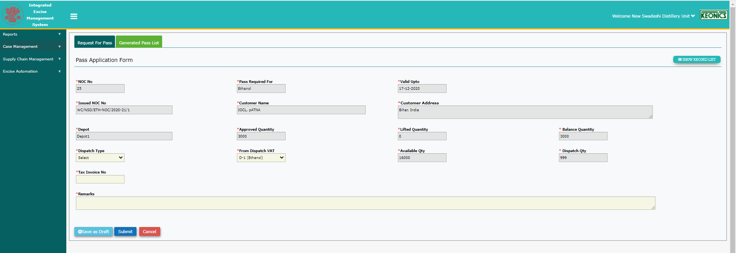

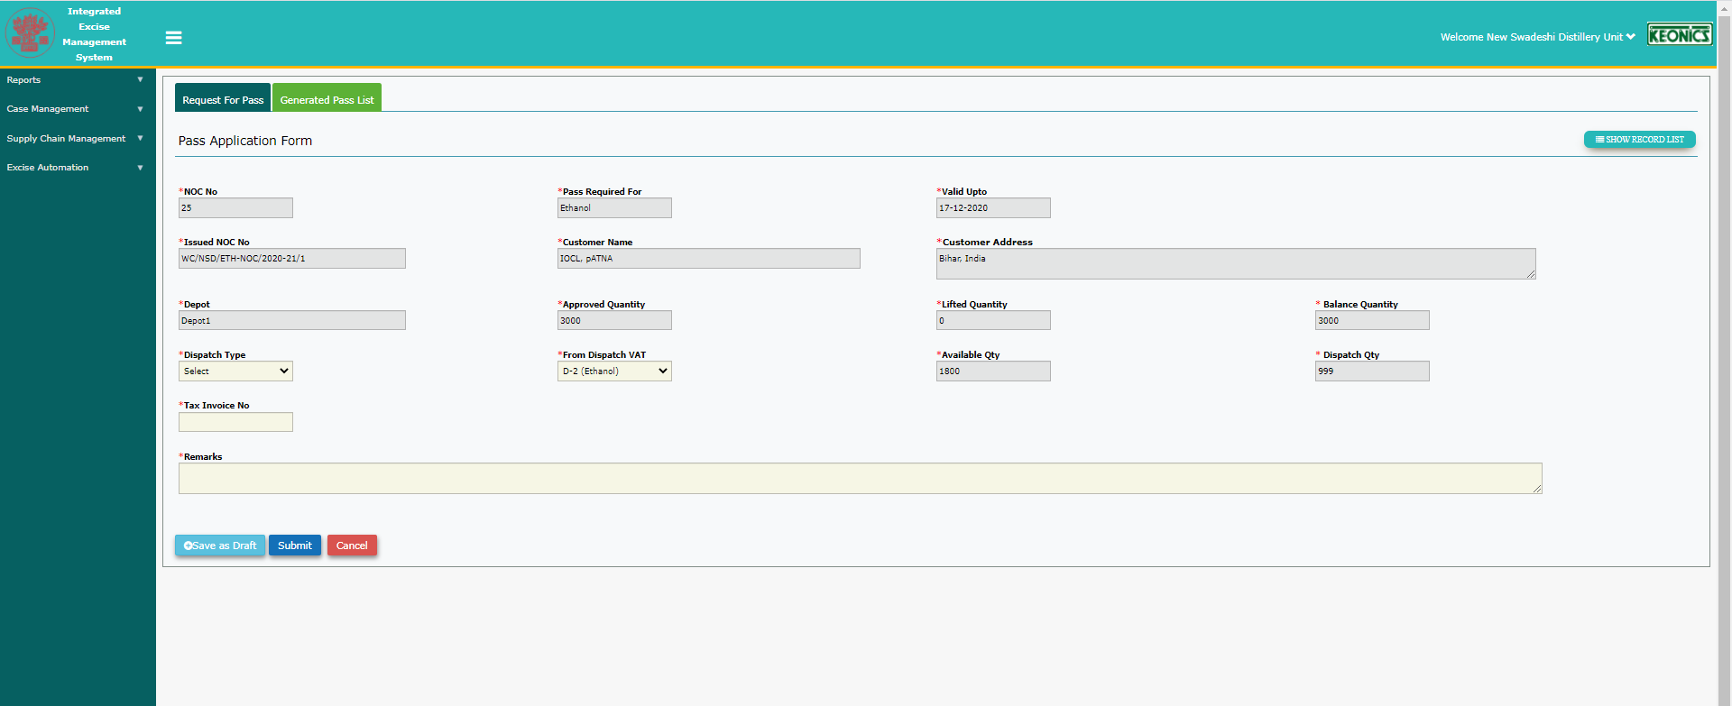

3)When Pass is raised through NOC for ethanol, a NOC No was displayed as WC/NSD/ETH-NOC/2020-21/1. When the same record is approved by bo and viewed in generate pass form , NOC No appears as 25. It should be correctly displayed in all related forms.

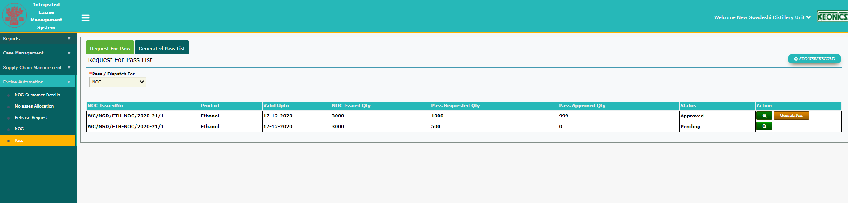

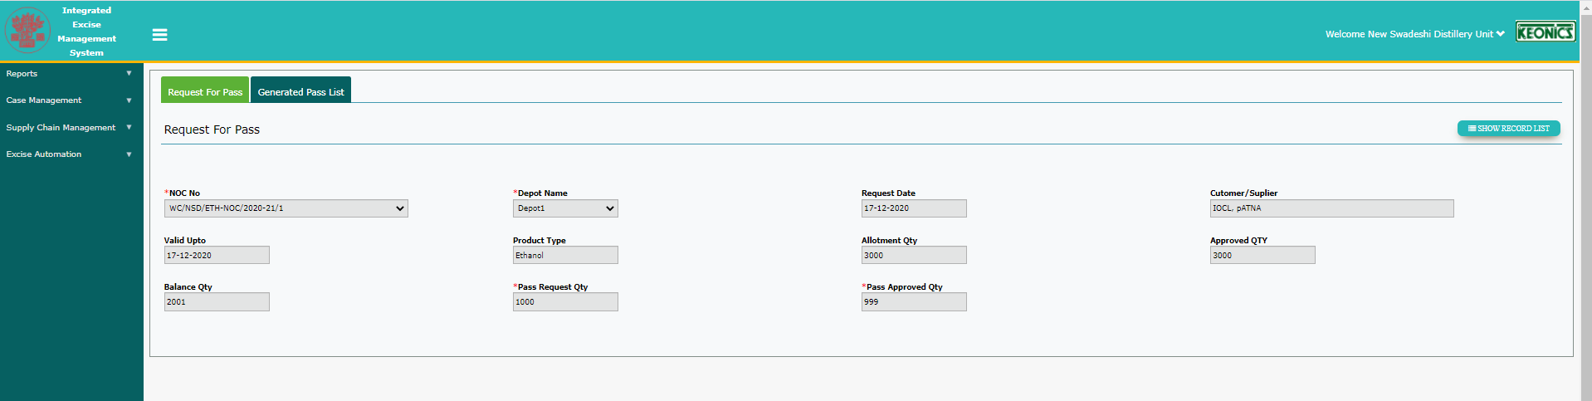

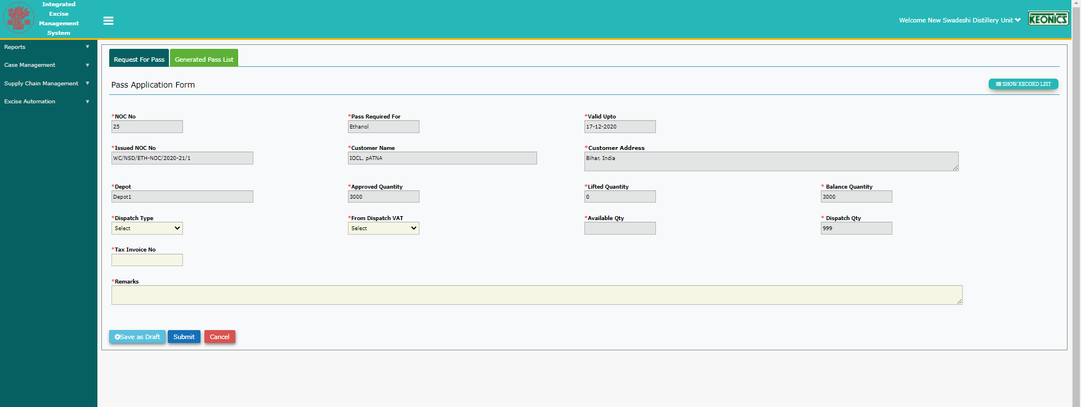

1. None of the fields have tooltips except Approved and Balance qty. Its wrongly displayed for both these fields as RR Approved Qty and RR balance qty.

Instead should display as NOC Approved Qty and NOC Balance Qty when pass is being raised through NOC and RR only when pass is being raised through RR.

Also requires tool tips throughout the application to maintain equality.

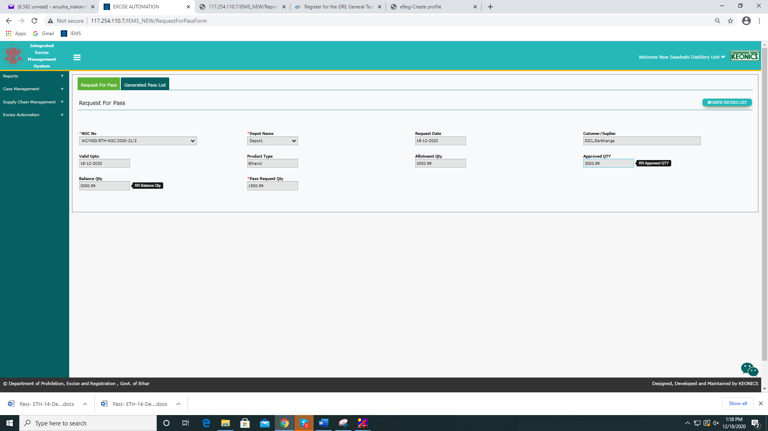

1. Pass requested qty was 1500.99 and Pass approved qty was 1000 and NOC Qty was 3000.99 from depot1.

The balance changes as soon as the user raises a request.

Initially distillery raised pass for 1500.99. I tried to add another and balance was displayed as 1500 and new request could be raised only based on the available balance.

Then the pass was approved for a qty of 1000.(A qty of 500.99 was not allotted)

This 500.99 cannot be requested for again currently.

There should be a provision to re-raise the qty that was not approved for.

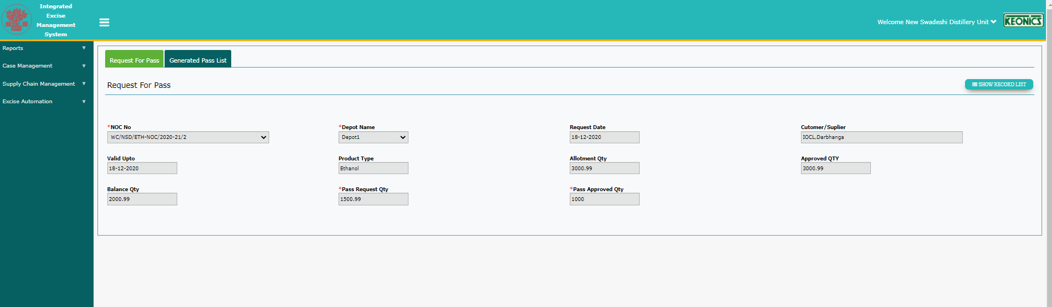

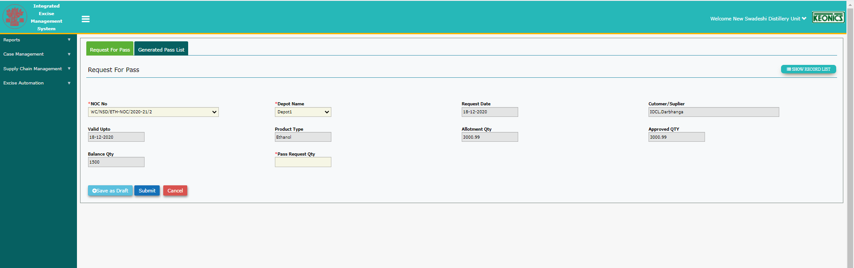

5)After BO has approved, click on generate pass in distillery login🡪 Fill details🡪 Save as Draft🡪Pass Applied List view🡪Issued PassNo is populated with a random NOC no inside the form. Firstly NOC No should be correctly populated(its application no 3) and this is not pass no and thus should not be populated in list view.

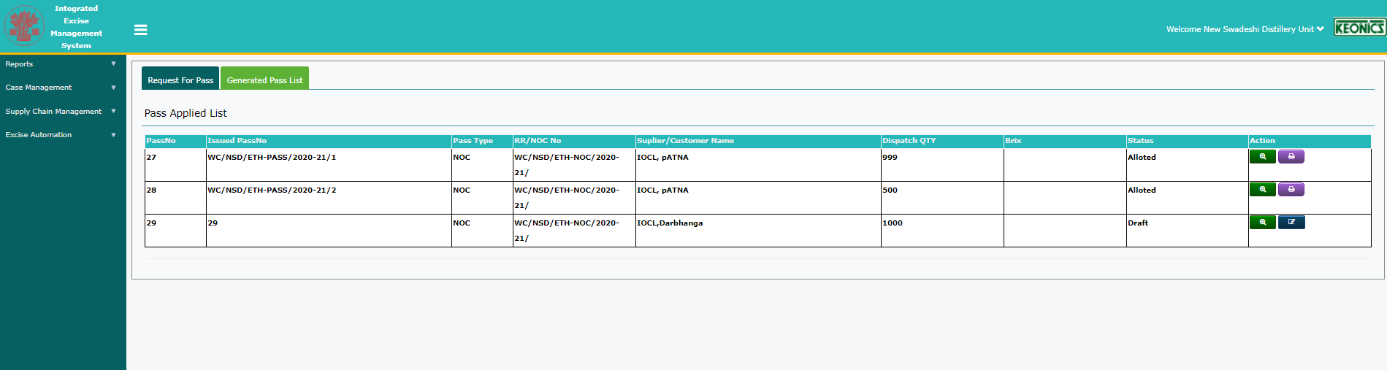

6)In distillery login🡪 Click on generate pass🡪 Fill details🡪 Save as Draft🡪 Click on NOC in the menu🡪 again navigate to pass list🡪 Instead of Save as draft mode, Generate pass reappears again, and if filled and submitted again, 2 records will be created for same pass raised.

Even if other menus are accessed, the save as draft should be retained for that record. Should not allow multiple records from one pass raised.

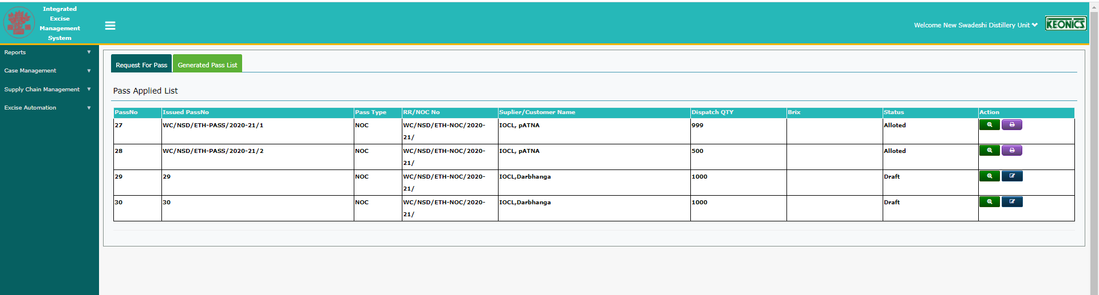

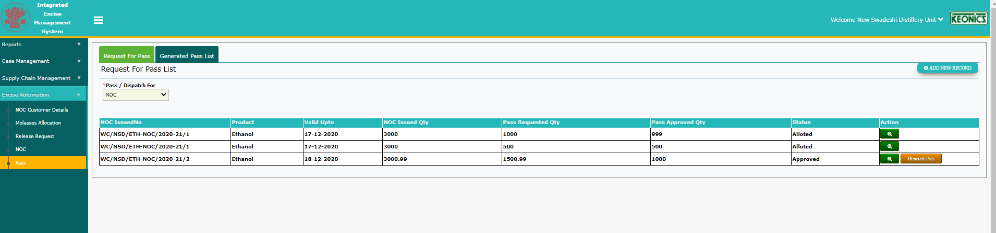

7)Tooltips in Generated Pass Application Form

NOC No has Release Request No.-🡪 To be changed to NOC No. for this form when accessed from NOC.

Issued NOC No🡪 To be changed to Issued NOC No. instead of Release Request no when accessed through NOC.

Customer Name 🡪 To be changed to Customer Name instead of Supplier name

Customer address->To be changed to Customer Address instead of Supplier Address

8) login as dis BO--->In the issue of pass->"pass Application form"-->"pass Approval" section---> DEFECTS

1) " Transport challan Bill No" field-->spelling mistake displayed as "Transport challan Bilty No" even in tooltip displayed the same. Alert message for the mandatory field also to be changed for the same.

2) "Route Details" field --->Font to be changed

3)Date of dispatch🡪the text box to be made read only and should allow to choose date only through calendar control UI.

Also allows to enter previous dates. Should restrict and allow to enter only current and future dates.

9) After clicking on Print Button, only partial pass appears for last 3 passes in the bottom. Full pass needs to be present.

Pass no generation is not in a sequence. Should start from 1 and be generated separately partwise.

Heading and Pass for field display Molasses-C-Heavy. It is generated for Ethanol.

3 fields are always empty as this data is not relevant- Year of production, BRIX, Sugar Content

Vehicle no field to be in caps if alphabets are entered.

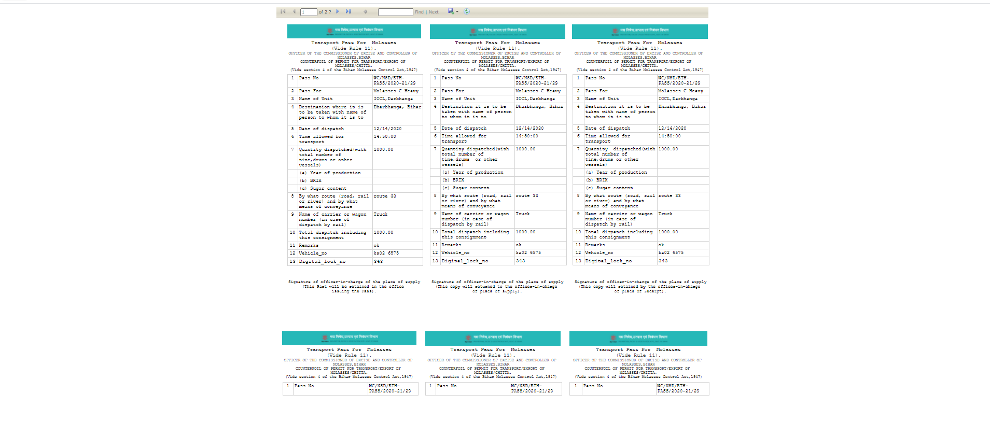

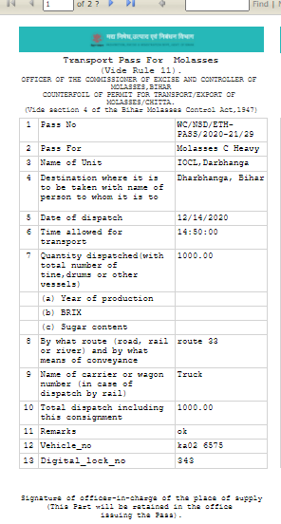

9) After pass is issued status should be changed to Issued from Allotted.

